33.52: a) The distance traveled by the light ray is the sum of the two diagonal segments:
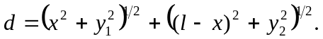
Then the time taken to travel that distance is just:
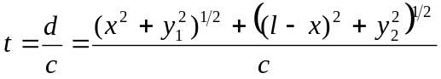
b) Taking the derivative with respect to x of the time and setting it to zero yields:
